**IBM CLOUD ACCOUNT CREATION TEAM ID:** PNT2022TIMID48112

**PROJECT NAME**: PERSONAL ASSISTANCE FOR SENIORS WHO ARE SELF–RELIANT

1. Created an IBM cloud account using cloud.ibm.com website

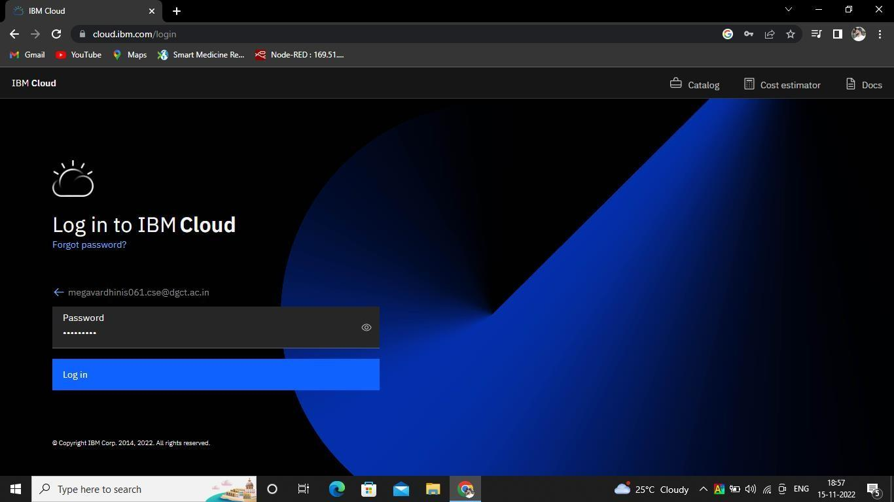

1. Dashboard of IBM Cloud Account

